🌿 Eco Track — Community-Driven Environmental

AI23431- WEBTECHNOLOGY AND MOBILE APPLICATION
MINI PROJECT REPORT
Submitted by

RAJESHGANESH S 241501161
SANJAY GP 241501179

in partial fulfillment of the award of the degree of

BACHELOR OF TECHNOLOGY

in

ARTIFIC IAL INTELLIGENCE MACHINE LEARNING


DEPARTMENT OF ARTIFICIAL INTELLIGENCE AND
MACHINE LEARNING
RAJALAKSHMI ENGINEERING COLLEGE, CHENNAI

An Autonomous Institute

CHENNAI - 602 105
MAY 2026

RAJALAKSHMI ENGINEERING COLLEGE
(An Autonomous Institution Affiliated to Anna University, Chennai)

BONAFIDE CERTIFICATE

Certified that this Project Thesis titled "🌿Eco Track — Community-Driven Environmental" is the Bonafide work of RAJESHGANESH S(241501161) and SANJAY GP(241501179) who carried out the work under my supervision. Certified further that to the best of my knowledge the work reported herein does not form part of any other thesis or dissertation on the basis of which a degree or award was conferred on an earlier occasion on this or any other candidate.

Dr. A RAJASEKARAN
Professor,
Department of Artificial Intelligence
and Machine Learning, Rajalakshmi Engineering College,
Chennai - 602105.

Submitted to Project Viva-Voce Examination held on …………………

INTERNAL EXAMINER EXTERNAL EXAMINER

11

ACKNOWLEDGEMENT

Initially we thank the Almighty for being with us through every walk of our life and showering his blessings through the endeavour to put forth this report. Our sincere thanks to our Chairman Mr. S. MEGANATHAN, B.E, F.I.E., our Vice Chairman Mr. ABHAY SHANKAR MEGANATHAN,
B.E., M.S., and our respected Chairperson Dr. (Mrs.) THANGAM MEGANATHAN, Ph.D., for providing us with the requisite infrastructure and sincere endeavouring in educating us in their premier institution.

Our sincere thanks to Dr. S.N. MURUGESAN, M.E., Ph.D., our beloved Principal for his kind support and facilities provided to complete our work in time. We express our sincere thanks to Dr. K. SEKAR, Ph.D., Professor and Head of the Department of Artificial Intelligence and Machine Learning for his guidance and encouragement throughout the project work. We convey our sincere and deepest gratitude to our internal guide,
Dr. A. RAJASEKARAN, Department of Artificial Intelligence and Machine Learning for his useful tips during our review to build our project.

RAJESHGANESH S – 241501161
SANJAY GP – 241501179

III

DEPARTMENT VISION

To promote highly Ethical and Innovative Computer Professionals through excellence in teaching, training and research.

DEPARTMENT MISSION
- To produce globally competent professionals who are motivated to learn emerging technologies and demonstrate innovation in solving real-world problems.

- To promote research activities among students and faculty members that contribute meaningfully to society.

- To instill strong moral and ethical values in professional practice.

PROGRAMME EDUCATIONAL OBJECTIVES(PEO’S)

PEO 1: To equip students with essential background in computer science, basic electronics and applied mathematics.
PEO 2: To prepare students with fundamental knowledge in programming languages, and tools and enable them to develop applications.
PEO 3: To encourage the research abilities and innovative project development in the field of AI, ML, DL, networking, security, web development, Data Science and also emerging technologies for the cause of social benefit.
PEO 4: To develop professionally ethical individuals enhanced with analytical skills, communication skills and organizing ability to meet industry.

IV

PROGRAMME OUTCOMES (POs)

PO 1: Engineering knowledge: Apply the knowledge of Mathematics, Science, Engineering fundamentals, and an engineering specialization to the solution of complex engineering problems.

PO 2: Problem analysis: Identify, formulate, review research literature, and analyze complex engineering problems reaching substantiated conclusions using first principles of mathematics, natural sciences, and engineering sciences.

PO 3: Design/development of solutions: Design solutions for complex engineering problems and design system components or processes that meet the specified needs with appropriate consideration for the public health and safety, and the cultural, societal, and environmental considerations.

PO 4: Conduct investigations of complex problems: Use research-based knowledge and research methods including design of experiments, analysis and interpretation of data, and synthesis of the information to provide valid conclusions.

PO 5: Modern tool usage: Create, select, and apply appropriate techniques, resources, and modern engineering and IT tools including prediction and modeling to complex engineering activities with an understanding of the limitations.

PO 6: The engineer and society: Apply reasoning informed by the contextual knowledge to assess societal, health, safety, legal and cultural issues and the consequent responsibilities relevant to the professional engineering practice.

V

PO 7: Environment and sustainability: Understand the impact of the professional engineering solutions in societal and environmental contexts, and demonstrate the knowledge of, and need for sustainable development.
PO 8: Ethics: Apply ethical principles and commit to professional ethics and responsibilities and norms of the engineering practice.

PO 9: Individual and team work: Function effectively as an individual, and as a member or leader in diverse teams, and in multidisciplinary settings.

PO 10: Communication: Communicate effectively on complex engineering activities with the engineering community and with society at large, such as, being able to comprehend and write effective reports and design documentation, make effective presentations, and give and receive clear instructions.

PO 11: Project management and finance: Demonstrate knowledge and understanding of the engineering and management principles and apply these to one’s own work, as a member and leader in a team, to manage projects and in multidisciplinary environments.

PO 12: Life-long learning: Recognize the need for, and have the preparation and ability to engage in independent and life-long learning in the broadest context of technological change.

VI

PROGRAM SPECIFIC OUTCOMES (PSOs)

A graduate of the Artificial Intelligence and Machine Learning Program will demonstrate

PSO 1: Foundation Skills: Ability to understand, analyze and develop computer programs in the areas related to algorithms, system software, web design, AI, machine learning, deep learning, data science, and networking

PSO 2: Problem-Solving Skills: Ability to apply mathematical methodologies to solve computational task, model real world problem using appropriate AI and ML algorithms. To understand the standard practices and strategies in project development, using open- ended programming environments to deliver a quality product.

PSO 3: Successful Progression: Ability to apply knowledge in various domains to identify research gaps and to provide solution to new ideas, inculcate passion towards higher studies, creating innovative career paths to be an entrepreneur and evolve as an ethically social responsible AI and ML professional.

VII

COURSE OBJECTIVE

- To identify and formulate real-world problems that can be solved using Artificial Intelligence and Machine Learning techniques.
- To apply theoretical and practical knowledge of AI/ML for designing innovative, data-driven solutions.
- To integrate various tools, frameworks, and algorithms to develop, test, and validate AI/ML models.
- To demonstrate effective teamwork, project management, and communication skills through collaborative project execution.
- To instill awareness of ethical, societal, and environmental considerations in the design and deployment of intelligent systems.

COURSE OUTCOME

- CO 1: Analyze and define a real-world problem by identifying key challenges, project requirements and constraints.
- CO 2: Conduct a thorough literature review to evaluate existing solutions, identify research gaps and formulate research questions.
- CO 3: Develop a detailed project plan by defining objectives, setting timelines, and identifying key deliverables to guide the implementation process.
- CO 4: Design and implement a prototype or initial model based on the proposed solution framework using appropriate AI tools and technologies.

VIII

CO 5: Demonstrate teamwork, communication, and project management skills by preparing and presenting a well-structured project proposal and initial implementation results

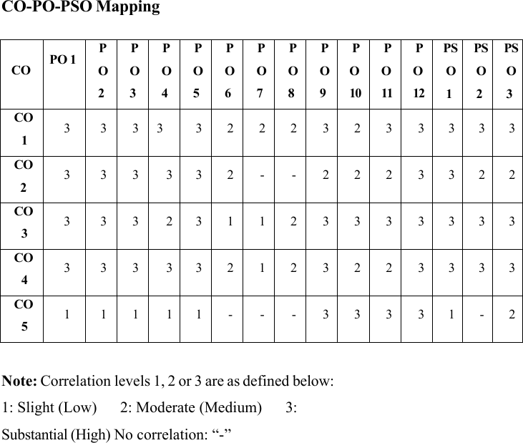

IX

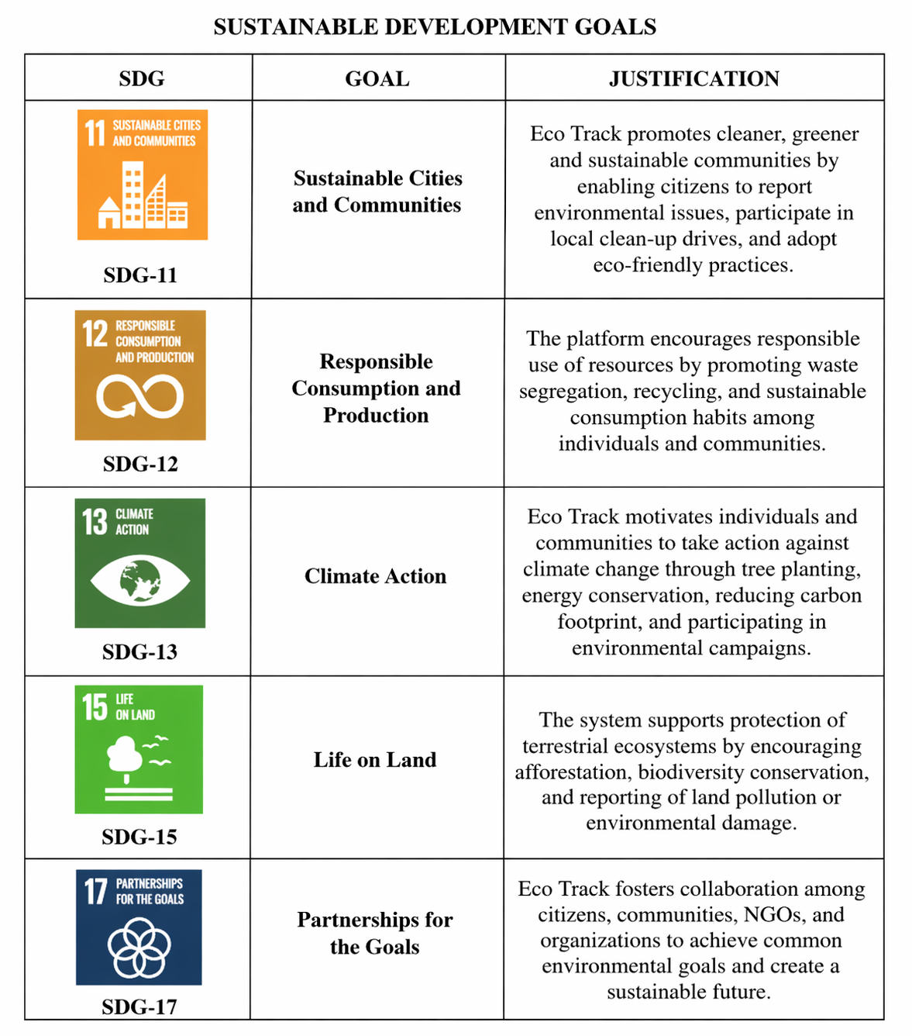

X

ABSTRACT

Eco Track — Community-Driven Environmental Action is a digital platform designed to promote environmental awareness, sustainability, and active participation from communities. With growing concerns about climate change, pollution, and resource depletion, the system provides a centralized and user-friendly solution for individuals and organizations to collaborate on environmental initiatives. The platform replaces fragmented efforts with an organized and technology-driven approach to track, manage, and encourage eco-friendly activities.

The application enables users to log and monitor their environmental contributions, such as waste management, tree planting, water conservation, and energy-saving practices. Through role-based access, community members, volunteers, and administrators can securely interact within the system. Users can participate in local campaigns, report environmental issues, and track their personal impact through an interactive dashboard.

Eco Track includes features such as real-time activity tracking, community challenges, and reward systems to motivate sustainable behavior. Users can view statistics on their contributions, compare progress with others, and engage in discussions through an integrated communication interface. Additionally, the system supports notifications and alerts to keep users informed about upcoming events, environmental campaigns, and important updates.

The architecture of the platform is designed to be scalable, efficient, and accessible on standard devices, ensuring ease of use across diverse user groups. By maintaining centralized data and providing analytical insights, Eco Track helps communities identify environmental trends and take informed actions. Overall, the system enhances environmental responsibility, fosters collaboration, and empowers individuals to contribute effectively toward a sustainable future.

XI

TABLE OF CONTENTS

SI NO | TITLE | PAGE NO
 | ACKNOWLEDGEMENT | iii
 | ABSTRACT | xi
 | LIST OF ABBREVIATIONS | 1
1 | INTRODUCTION | 2
1.1 | General | 2
1.2 | Need for project | 2
1.3 | Scope of the system | 3
1.4 | Organization of report | 4
2 | LITERATURE SURVEY | 5
2.1 | Introduction | 5
2.2 | Existing Environment Monitoring System | 5
2.3 | Related work | 6
2.4 | Summary | 6
3 | PROBLEM FORMATION AND ORGANIZATION | 7
3.1 | Problem Statement | 7
3.2 | Objectives of Eco Track | 7
4 | SYSTEM DESIGN | 8
4.1 | Introduction | 8
4.2 | System Architecture | 8
4.3 | Database Design | 8
4.4 | System Requirements | 9
4.4.1 | Hardware Requirements | 9
4.4.2 | Software Requirement | 9
5 | SYSTEM IMPLEMENTATION | 10
5.1 | System Methodology | 10
5.2 | Module Description | 11
5.2.1 | User Module | 12
5.2.2 | Admin Module | 13
5.2.2.1 | Environmental Activity Tracking | 14
5.2.3 | Issue Reporting Module | 15
5.2.4 | Login and Authentication Module | 16
5.2.5 | Notification Module | 17
5.2.6 | Community Interactive Module | 18
6 | RESULTS AND DISCUSSION | 21
6.1 | System Output Screens | 21
6.2 | Performance Evaluation | 21
6.3 | System Testing | 22
7 | CONCLUSION AND FUTURE WORK | 23
7.1 | Conclusion | 23
7.2 | Future Enhancements | 23
 | REFERENCES | 23
 | APPENDICES | 24

LIST OF ABBREVIATIONS

ABBREVATION FULL FORM
ECO
TRACK Environmental Community Tracking System
DB Database
SQL Structured Query Language
API Application Programming Interface
UI User Interface
UX User Experience
HTML Hyper Text Markup Language
CSS Cascading Style Sheets
JS JavaScript
HTTP Hyper Text Transfer Protocol
SMTP Simple Mail Transfer Protocol
GPS Global Positioning System
GIS Geographic Information System
CRUD Create, Read, Update, Delete

CHAPTER 1

INTRODUCTION

1.1 General
Environmental sustainability has become a major concern in recent years due to increasing pollution, climate change, and resource depletion. Communities play a vital role in protecting the environment, but lack of awareness, coordination, and proper tools often limits their participation. Traditional environmental efforts are usually unorganized and difficult to track, making it hard to measure their impact.
Eco Track — Community-Driven Environmental Action is designed to provide a digital platform that enables individuals and communities to actively participate in environmental protection. The system allows users to record eco-friendly activities such as tree planting, waste management, and energy conservation. It also provides a centralized dashboard where users can track their contributions and monitor environmental progress.
By maintaining data in a centralized system, Eco Track ensures accuracy, easy access, and efficient management of environmental activities. The system reduces manual effort, improves awareness, and promotes sustainable practices through a user-friendly interface.

1.2 Need for Eco Track System
Many communities lack a proper system to monitor and manage environmental activities. Environmental efforts such as waste management, recycling, and conservation are often done without proper tracking, leading to inefficiency and lack of accountability.
A digital platform like Eco Track helps overcome these limitations by providing a structured and organized solution. Users can record their activities, monitor progress, and participate in environmental campaigns. The system also enables administrators to8 analyze data and identify areas that require improvement.
The system improves awareness, encourages responsible behavior, and promotes transparency in environmental actions. It also reduces manual effort and helps communities work together toward sustainability goals.

1.3 Scope of the System
Eco Track is developed to simplify the process of recording, monitoring, and managing environmental activities within communities. The system provides secure login access for users and administrators.
Users can record eco-friendly activities, view their contributions, and participate in campaigns. Administrators can monitor overall activities, manage users, and analyze environmental data. The system maintains a centralized database where all information is stored securely.
The scope of the system includes promoting environmental awareness, improving community participation, reducing environmental impact, and providing easy access to environmental data. It can be implemented in communities, educational institutions, and organizations.

1.4 Organization of the Report
This report is organized into several chapters that describe the development and implementation of Eco Track.

- Chapter 1: Introduction, need, and scope of the system
- Chapter 2: Literature survey and related work
- Chapter 3: Problem formulation and objectives
- Chapter 4: System design and architecture
- Chapter 5: System implementation and modules
- Chapter 6: Results and performance evaluation
- Chapter 7: Conclusion and future enhancements

CHAPTER 2

LITERATURE SURVEY

2.1 Introduction

Environmental monitoring and management have become important areas of research due to increasing environmental challenges. Traditional methods of tracking environmental activities are often manual and lack proper coordination.
With advancements in technology, digital platforms and smart systems have been developed to monitor environmental conditions and activities. These systems help improve awareness, accuracy, and efficiency in environmental management.

2.2 Existing Environmental Monitoring Systems

Several systems have been developed to monitor environmental conditions and activities. Some systems use IoT sensors to track pollution levels, temperature, and air quality. These systems provide real-time data and help authorities take necessary actions.
Other platforms focus on community participation by allowing users to report environmental issues such as waste dumping and pollution. These systems help improve communication and encourage public involvement in environmental protection.

2.3 Related Work

Many research studies highlight the importance of community-driven environmental platforms. These studies show that digital systems improve participation, awareness, and data management.
Some systems integrate technologies like GIS, mobile applications, and cloud computing to provide real-time monitoring and reporting. These approaches help in efficient data collection and analysis, enabling better decision-making.

2.4 Summary

The literature survey shows that digital environmental systems provide better efficiency compared to traditional methods. They improve data accuracy, enable real-time monitoring, and encourage community participation.
However, many existing systems focus only on monitoring and lack features for user engagement and activity tracking. Therefore, Eco Track provides a simple and effective solution by combining activity tracking, community interaction, and environmental awareness.

.

CHAPTER 3

PROBLEM FORMULATION AND OBJECTIVES

3.1 Problem Statement
Environmental issues such as pollution, waste management, and deforestation are increasing due to lack of awareness and organized efforts. Many communities do not have a proper system to track environmental activities or measure their impact.
Traditional methods are inefficient, unorganized, and lack transparency. It is difficult to monitor participation, analyze data, and ensure accountability. This leads to reduced effectiveness of environmental initiatives.
Therefore, there is a need for a digital system that can help track environmental activities, encourage participation, and provide meaningful insights.

3.2 Objectives of the System
The main objective of Eco Track is to develop a platform that promotes environmental awareness and community participation.
The specific objectives include:
• To record and track environmental activities
• To provide secure login access for users
• To enable users to monitor their contributions
• To encourage sustainable practices
• To improve environmental awareness and participation
    - .

CHAPTER 4

SYSTEM DESIGN

4.1 Introduction
System design defines the structure and components of the application. It explains how different parts of the system interact and how data is processed.
Eco Track is designed as a web-based application that allows users to record and monitor environmental activities. The system follows a structured design to ensure efficiency and reliability.

4.2 System Architecture
The system follows a three-layer architecture:

• Presentation Layer:
This layer includes the user interface where users interact with the system. It consists of web pages such as login, dashboard, and activity tracking pages developed using HTML, CSS, and JavaScript.

• Application Layer:
This layer handles system logic such as user authentication, activity tracking, and data processing. It is implemented using Node.js.

• Database Layer:
This layer stores all data including user details, activities, and reports. The database ensures secure and efficient data management.

This architecture ensures smooth communication between users and the database while maintaining system efficiency and reliability.

4.3 System Requirements

4.3.1 Hardware Requirements
• Processor: Intel Core i3 or higher
• RAM: Minimum 4 GB
• Storage: 500 GB Hard Disk or SSD
• Input Devices: Keyboard and Mouse
• Internet Connection

4.3.2 Software Requirements
• Operating System: Windows 10 or later
• Frontend: HTML, CSS, JavaScript
• Backend: Node.js
• Database: MySQL
• IDE: Visual Studio Code
• Browser: Google Chrome

CHAPTER 5

SYSTEM IMPLEMENTATION

5.1 System Methodology
The Eco Track System is implemented as a web-based application designed to monitor, analyze, and manage environmental data such as carbon emissions, energy consumption, and waste management. The system allows users to access the platform through web browsers, ensuring ease of use and accessibility from different devices.

The development process involves three major components: frontend design, backend development, and database integration. The frontend is developed using HTML, CSS, and JavaScript to provide an interactive and user-friendly interface. It enables users to input environmental data, view reports, and monitor their eco-friendly activities.

The backend of the system is implemented using Node.js, which handles core functionalities such as user authentication, data processing, report generation, and communication with the database. The backend ensures that all environmental data is processed efficiently and securely.

The system uses a MySQL database to store user details, environmental records, activity logs, and performance reports. This helps in maintaining accurate records and enables quick retrieval of data for analysis.

The Eco Track System follows a modular architecture where each functionality is developed as an independent module. This approach improves system scalability, maintainability, and allows easy integration of future enhancements such as AI-based predictions or IoT-based data collection.

5.2 Module Descriptions
The Eco Track System consists of several modules that work together to promote environmental awareness and efficient tracking of eco-friendly activities.
Index Module
The Index Module serves as the main entry point of the Eco Track System. It provides a user-friendly interface that introduces users to the system and its environmental objectives before logging in.
The homepage displays the system title along with key features such as:
- Carbon Footprint Tracking
- Real-time Environmental Statistics
- Waste Management Monitoring
- Energy Consumption Analysis
- Secure User Login
- Eco-friendly Activity Suggestions
Below the feature section, the page provides login options such as:
- User Login: Allows individuals to track their daily activities, monitor carbon footprint, and view reports.
- Admin Login: Enables administrators to manage users, monitor overall system data, and generate environmental reports.
This module acts as a gateway that directs users to their respective dashboards based on their roles. The design is simple, visually appealing, and ensures easy navigation for all users.



5.2.1 User Module
The User Module allows individuals to access the Eco Track System through a secure login interface. After logging in, users can enter and monitor their daily environmental activities such as energy consumption, waste generation, water usage, and carbon footprint.
This module provides a personalized dashboard where users can view their activity history, environmental impact reports, and overall sustainability score. It helps users understand how their daily habits affect the environment.
The User Module improves awareness and transparency by enabling users to regularly track their eco-friendly practices. It also encourages users to adopt sustainable behaviors by providing insights and suggestions to reduce their environmental impact.

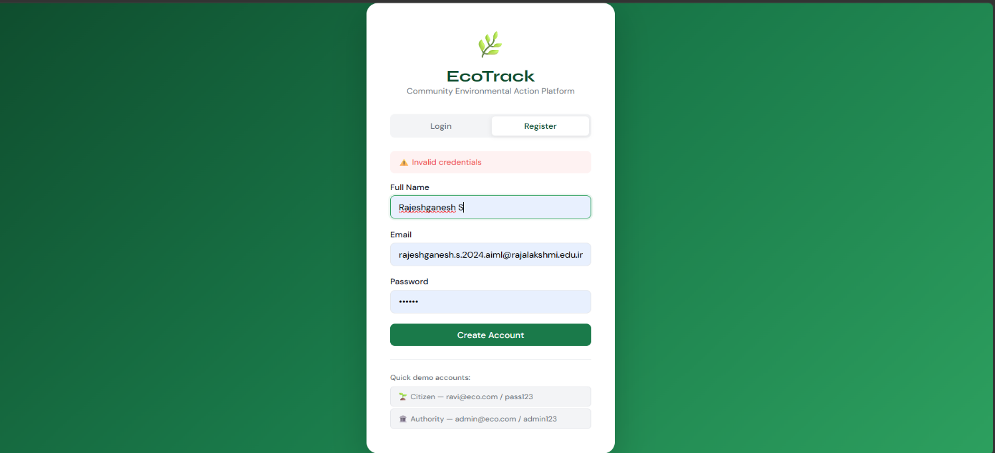
5.2.2 Admin Module
The Admin Module allows administrators to manage and control the overall functioning of the Eco Track System through a secure login system. After logging in, the admin can monitor user activities, manage user accounts, and oversee environmental data recorded in the system.
This module provides access to system-wide data such as total carbon footprint, energy consumption statistics, and waste management reports. The admin can also add, update, or delete user information and ensure that all data is accurate and properly maintained.
Additionally, the Admin Module enables the generation of reports and analysis of environmental trends, which helps in making informed decisions for improving sustainability practices. It also ensures system security and proper functioning by managing user permissions and maintaining data integrity.


5.2.2.1 – Environment Activity Tracking

The system allows users to select the date and time slot before recording any environmental activity.
Based on the selected time slot, the system automatically identifies the type of activity (such as energy usage, waste disposal, or water consumption).

It uses predefined schedules or user activity patterns to determine the correct activity category.

- The system auto-fills or suggests the activity type, reducing the need for manual selection.
- It helps in reducing input errors and ensures accurate recording of environmental data.
- The feature saves time and makes the tracking process faster and more efficient.
- It is especially useful for users who perform multiple eco-friendly activities in a day
Overall, this feature improves usability, accuracy, and efficiency of the Environment Activity Tracking system.

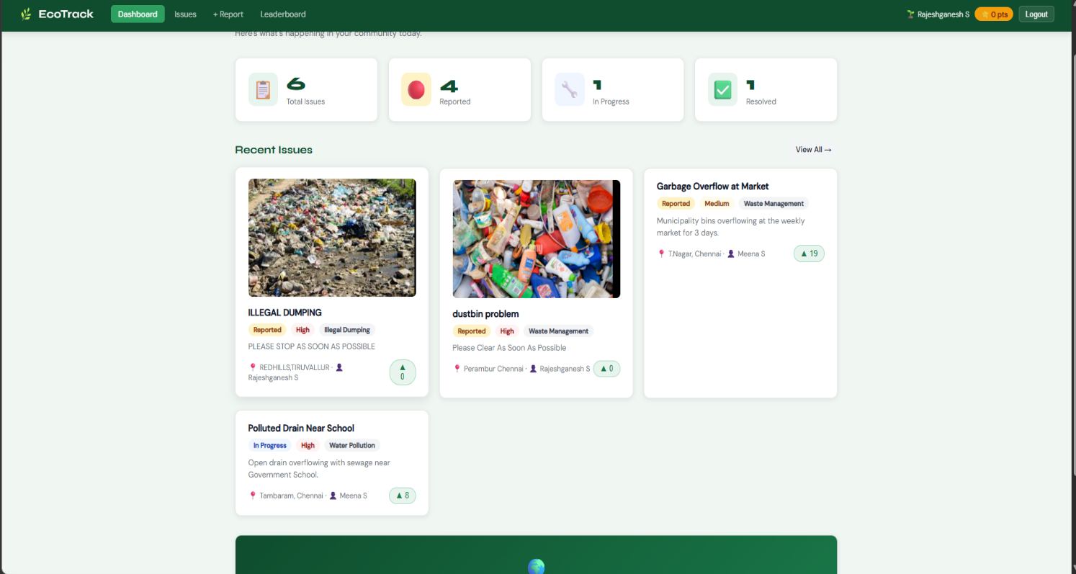

5.2.3 Issue Reporting Module
- Allows users to report environmental issues such as pollution, waste dumping, or water leakage.
- Provides a simple interface to submit complaints with details like location, description, and images.
- Helps authorities or admins to monitor and take action on reported issues.
- Maintains a record of all reported problems for future reference.
- Improves community participation in maintaining a clean and sustainable environment.
.

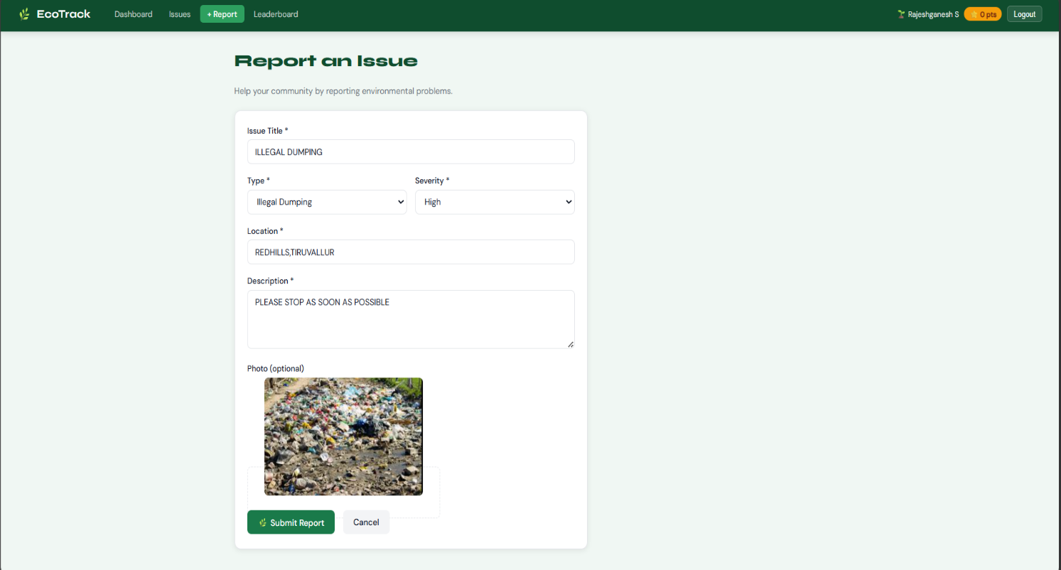

5.2.4 Login and Authentication Module

- Provides secure access to the system through user login credentials.
- Ensures only authorized users can access system features.
- Supports role-based access (User/Admin).
- Protects user data and prevents unauthorized usage.
- Enhances system security using authentication mechanisms.



5.2.5 Notification Module

- Sends alerts and notifications to users regarding environmental activities.
- Notifies users about reminders for tracking activities or updates.
- Provides alerts for reported issues and their status.
- Can include email or in-app notifications.
- Helps users stay informed and engaged with the system.

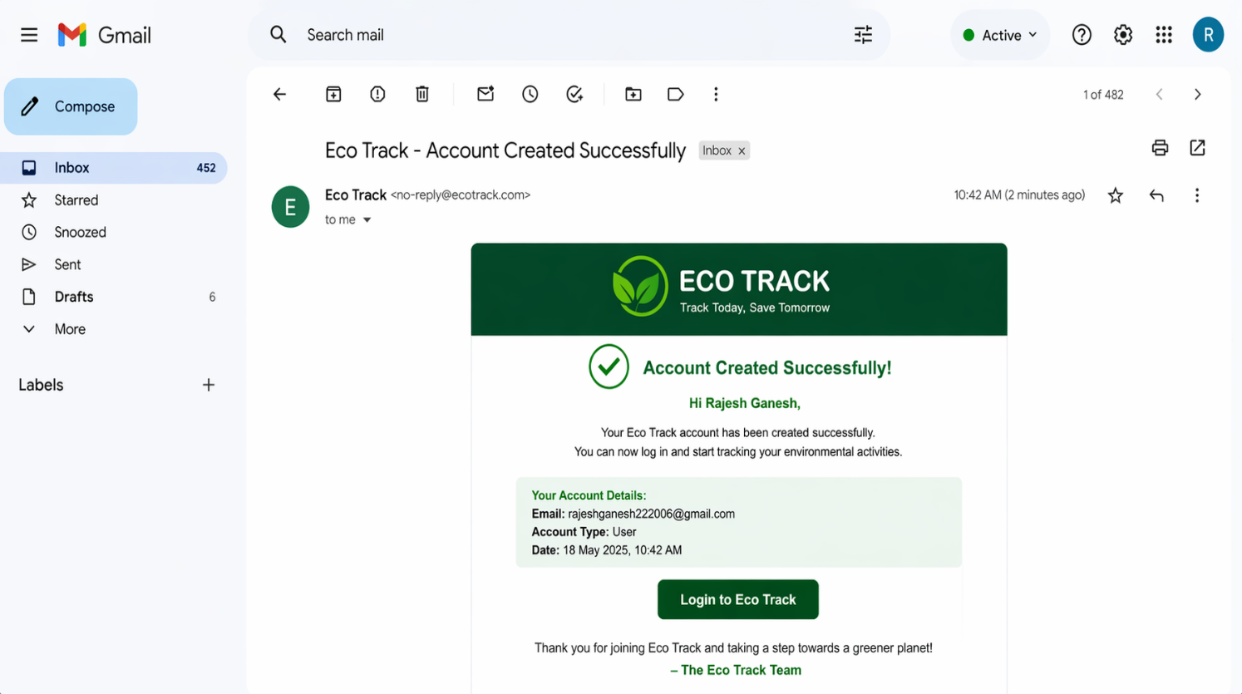
5.2.6 Community Interactive Module

- Enables users to interact and share eco-friendly ideas and practices.
- Provides a platform for discussions related to environmental awareness.
- Encourages collaboration and community participation.
- Allows users to share tips, suggestions, and success stories.
- Promotes awareness and motivates users towards sustainable living.
.


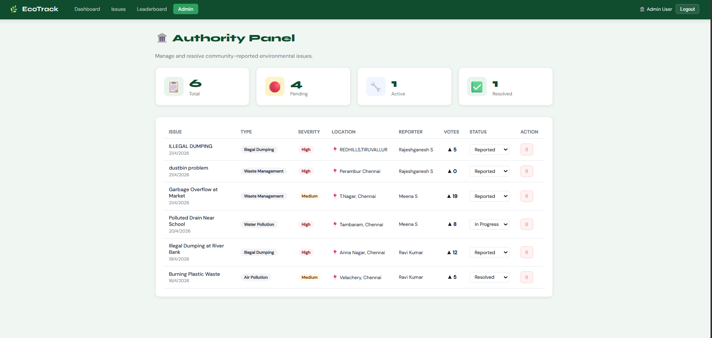

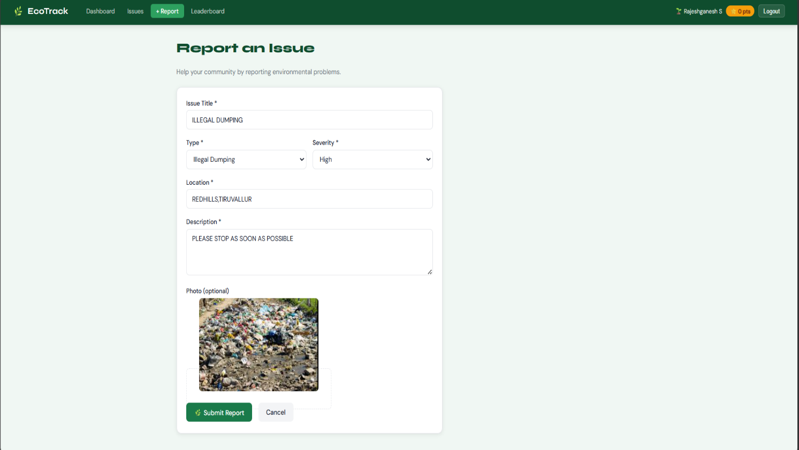
CHAPTER 6
RESULTS AND DISCUSSION
6.1 Results
The Eco Track System was successfully developed and tested as a web-based application for tracking environmental activities and promoting sustainable practices. The system enables users to record their daily eco-friendly activities such as energy consumption, waste management, and water usage.
During testing, the system performed efficiently in handling user login, activity tracking, and data storage. Users were able to enter their environmental activities, and the system stored the data accurately in the database. The dashboard provided clear insights into user activities and environmental impact.
The system also supports additional features such as email notifications, issue reporting, and community interaction. These features enhance user engagement and promote awareness about environmental sustainability.
Overall, the Eco Track System successfully achieved its objective of simplifying environmental activity tracking and encouraging users to adopt eco-friendly habits.
6.2 Performance Evaluation
The performance of the Eco Track System was evaluated based on usability, accuracy, and response time. The system provides a simple and user-friendly interface that allows users and administrators to interact with the application
Environmental data is stored in a centralized database, ensuring accurate record maintenance and quick data retrieval. The use of Node.js for backend processing enables efficient handling of user requests and real-time updates without delays.

Testing results show that the system performs reliably under normal usage conditions. The activity tracking, reporting, and notification features function smoothly. The modular design ensures that new features can be added in the future without affecting system performance.

6.3 Resource Utilization

The Eco Track System is designed to operate on standard computer systems without requiring high-end hardware. The application uses lightweight technologies such as HTML, CSS, and JavaScript for the frontend, while Node.js manages backend operations efficiently.

The database stores environmental data in an optimized manner, ensuring minimal memory usage and efficient processing. The system maintains good performance even on basic hardware configurations.

Since the system is web-based, users can access it through a browser without installing additional software. This makes the system cost-effective, accessible, and resource-efficient for individuals and organizations.

CHAPTER 7

CONCLUSION AND FUTURE WORK

7.1 Conclusion

The Eco Track System was developed to provide an effective solution for monitoring and managing environmental activities. The system replaces manual tracking methods with a digital platform that simplifies the process of recording, analyzing, and accessing environmental data.

The application allows users to track their daily eco-friendly activities while enabling administrators to monitor overall environmental impact. By maintaining data in a centralized database, the system ensures accuracy, transparency, and quick access to information.

The implementation of the system reduces manual effort, improves awareness, and encourages sustainable behavior among users. The web-based design makes the system easy to use, accessible, and suitable for promoting environmental responsibility.

7.2 Future Work
Although the current system provides essential features for environmental activity tracking, several improvements can be made in the future to enhance its capabilities.

Future enhancements may include integrating IoT sensors to automatically collect environmental data such as air quality, energy usage, and water consumption. A mobile application can also be developed to allow users to track activities conveniently through smartphones.

REFERENCES

[1] J. A. Turner and K. P. Singh, “Smart Environmental Monitoring Systems Using IoT: A Review,” International Journal of Environmental Science and Technology, vol. 18, no. 3, pp. 1025–1040, 2021.
[2] S. Madakam, R. Ramaswamy, and S. Tripathi, “Internet of Things (IoT): A Literature Review,” Journal of Computer and Communications, vol. 3, no. 5, pp. 164–173, 2015.
[3] A. Kumar and P. Sharma, “Environmental Monitoring and Pollution Control Using Smart Technologies,” International Journal of Advanced Research in Computer Science, vol. 9, no. 2, pp. 45–50, 2018.
[4] Node.js Documentation, “Node.js Official Documentation,” Available: https://nodejs.org
[5] MySQL Documentation, Oracle Corporation, “MySQL Reference Manual,” Available: https://dev.mysql.com/doc
[6] World Wide Web Consortium, “HTML (HyperText Markup Language) Specification,” Available: https://www.w3.org
[7] D. Flanagan, JavaScript: The Definitive Guide, 7th ed., O’Reilly Media, 2020.
[8] United Nations Environment Programme (UNEP), “Global Environment Outlook Report,” Available: https://www.unep.org
[9] World Health Organization (WHO), “Air Quality and Environmental Health,” Available: https://www.who.int

APPENDICES

Appendix-1: Source Code Pseudocode

System Overview
The Eco Track System is developed to monitor and manage environmental activities efficiently using an automated and structured process. The system provides secure login access for users and administrators. Users can record daily eco-friendly activities such as energy usage, waste management, and water consumption, while administrators can monitor system-wide environmental data.

The system also prevents duplicate activity entries, records time-based activity data, and sends automatic email notifications for important updates. The backend is implemented using Node.js and MySQL, while the frontend provides a responsive and user-friendly interface.

System Initialization Logic

START
Connect to MySQL database
IF database connection is successful
→ Start server on port 3000
→ Load system homepage (index.html)
ELSE
→ Display database connection error
END IF
END

User Login Logic

FUNCTION Login(email, password, role)
IF role = user
→ Check user table for matching email and password
ELSE IF role = admin
→ Check admin table for matching email and password
END IF
IF credentials are valid
→ Create user session
→ Redirect to dashboard
ELSE
→ Display “Invalid login credentials”
END IF
END FUNCTION

Activity Tracking Logic

FUNCTION TrackActivity(user_id, activity_type, date, time, value)
Search activity table where
user_id = user_id AND activity_type = activity_type AND date = date
IF record exists
→ Update activity value
→ Update time
→ Return “Activity updated successfully”
ELSE
→ Insert new activity record
→ Return “Activity recorded successfully”
END IF
END FUNCTION

Batch Activity Logging Logic

FUNCTION BatchTrackActivity(activity_list)
FOR each activity in activity_list
→ Call TrackActivity(user_id, activity_type, date, time, value)
IF activity exceeds limit
→ Call SendNotification(user)
END IF
END FOR
Return summary report
END FUNCTION

Duplicate Activity Prevention Logic

Database Constraint: UNIQUE(user_id, activity_type, date)
IF duplicate entry attempted
→ Prevent insertion
→ Update existing record
END IF
Result: Duplicate activity entries are avoided and data remains accurate

Email Notification Logic

FUNCTION SendNotification(user)
IF activity limit exceeded OR important update
→ Prepare email containing
• User name
• Activity details
• Date and time
• Environmental impact
→ Send email via SMTP server
→ Receiver: user email
END IF
END FUNCTION

Activity Viewing Logic
FUNCTION ViewActivity(user_id)
Retrieve activity records from database
Display:
• Activity type
• Date & time
• Value (energy, waste, etc.)
Calculate environmental score
Display dashboard statistics
END FUNCTION

Environmental Score Calculation Logic

FUNCTION CalculateScore(user_id)
total_activities = count of activities
eco_score = calculated based on eco-friendly actions
Return eco_score
END FUNCTION

Community Interaction Logic

FUNCTION PostMessage(user_id, message)
Insert post into community table
Store user_id, message, timestamp
Display post to all users
END FUNCTION

System Features Implemented

- Secure login system for users and admins
- Environmental activity tracking (energy, waste, water)
- Real-time dashboard statistics
- Duplicate data prevention
- Email notification system
- Community interaction platform
- Responsive user interface

Appendix-2: System Test Verification

Test Case 1: Activity Recording
Result: PASS – activity recorded successfully

Test Case 2: Duplicate Detection
Result: PASS – duplicate entry prevented and updated

Test Case 3: Batch Activity Logging
Result: PASS – multiple activities processed correctly

Test Case 4: Notification System
Result: PASS – alert/notification sent successfully

Test Case 5: Activity Viewing
Result: PASS – users can view activity details and statistics

Final System Statistics (Sample)
Total Activities Recorded = 620
Energy Tracking Records = 300
Waste Tracking Records = 180
Water Tracking Records = 140
Overall Eco Score Improvement = 88%

Final System Status

The Eco Track System has been fully developed and successfully tested. The system ensures secure access, accurate activity tracking, duplicate prevention, and efficient data management. The integration of notifications and real-time environmental statistics enhances user awareness and engagement.

With a responsive interface and reliable backend functionality, the system is ready for deployment and practical use for promoting environmental sustainability.

